Lost and Found Application Proposal:
Community Driven Item Recovery


Department of Computer Science and Engineering
California State University, Fullerton

Project Advisor: Lidia Morrison

Table of Contents
Table of Contents
Abstract .........................................................................................................................................4
1.0 Introduction..............................................................................................................................5
2.0 Problem Statement ..................................................................................................................7
2.1 Problem Definition.................................................................................................................7
2.2 Problem Rationale ................................................................................................................7
3.0 What is Known About the Problem ......................................................................................7
3.1 Research.................................................................................................................................7
3.1.1 “Utilizing Deep Learning for Data Asset Protection for Network Security” ..................7
3.1.2 “Design and Utilization of Real-Time Network Monitoring System” .............................8
3.1.3 “Using Devnet for Network Security Intrusion Detection” ............................................8
3.1.4 “Using Large Language Models for Cyber Security Dashboard” ..................................9
3.1.5 “Designing Vulnerability Management Dashboards for Security Analysts” ..................9
3.1.6 “Social Transparency in design for Security Systems and Network Monitoring”..................................................................................................................................10
4.0 Proposed Method of Solving the Problem ..........................................................................10
4.1 Project...................................................................................................................................10
4.2 Benefits, Significance, and Future .......................................................................................10
5.0 Objective.................................................................................................................................11
6.0 Activities ................................................................................................................................12
7.0 Development Environment ..................................................................................................13
8.0 Operational Environment ....................................................................................................14
9.0 Overall Description................................................................................................................14
9.1 General Overview ................................................................................................................14
9.2 Application Overview............................................................................................................15
10.0 Architecture Design.............................................................................................................15
11.0 UML Diagrams ....................................................................................................................16
11.1 Use Case Diagram ............................................................................................................17
11.2 Sequence Diagram ............................................................................................................18
12.0 Implementation ...................................................................................................................19
12.1 Sign-in Screen ...................................................................................................................19
12.2 Sign-up Screen ..................................................................................................................20

13.0 Testing and Integration.......................................................................................................38
14.0 Installation Instructions .....................................................................................................38
15.0 Recommendations for Enhancement ................................................................................38
16.0 References.............................................................................................................................39

Table of Figures
Table 1 Software Requirements for Lost and Found App 18
Table 2 Hardware Requirements for Lost and Found App 19

Abstract
Everyone has lost an item before they wish they could get back, and everyone has found something around that they would like to return to the owner. Solutions for this problem before have been things like lost and founds as well as bulletin boards, but we believe there could be an easier solution. Our app creates a centralized platform for reporting, returning, and claiming lost and found items. The app does this through a combination of GPS tracking, a user-friendly map system, as well as direct messaging for quick item recovery. The goal of our app is to simplify the lost and found process, increase the number of items recovered, and create a more connected and helpful community where users feel confident their belongings can be found and returned.
With the creation of our app we will aim to solve all of the aforementioned problems that a person might experience. Our app will allow people to return items to their owners and possibly have the same favor returned to them. We will allow people to save themselves money and stress by empowering everyone on campus to act as concerned citizens. Throughout deployment we will work to improve and maintain this product, including visual upgrades as well as functional improvements.

1.0 Introduction
Losing personal belongings on campus or in public is a very common and frustrating experience. Current methods are slow and unorganized, potentially involving frequent check-ins in the hope that someone has found and returned something you lost. Technology can streamline this process through a system of digital reporting and location tracking. Our app provides users with a convenient, organized, and secure way to report and locate items.
A digital lost-and-found system can significantly improve how students recover personal items. Mobile applications allow information to be shared instantly across a large community. Features such as maps and notifications reduce the need for manual searching. Centralizing reports helps users avoid checking multiple platforms. This approach modernizes the lost-and-found process for today’s campus environment.

1.1 Background
At our school, students must drop off found items at the campus police department, and the department posts them on their lost and found website. While helpful, this system can be slow, and many students never check the site. A lot of lost and found posts also appear on the school Reddit, indicating that students rely on multiple places to report or look for items. Because everything is spread out, many items are never returned. A centralized app with real-time updates, a map, and quick communication can make the process easier for both the finder and the owner.
Many students are unaware of official lost-and-found procedures on campus. Others may find the process inconvenient or time-consuming. As a result, found items are sometimes left unreported or posted informally online. These informal methods lack consistency and long-term visibility. A centralized application would unify these efforts into one reliable system.

1.2 Motivation
Students frequently lose items such as keys, IDs, and phones, causing frustration. There is a lack of a unified platform for lost and found management, and because of this, many items never make it back to their owners. Our app aims to create a place where people can help one another out of a frustrating situation. We can also have instant reporting of lost and found items, easy item verification, and in app messaging for communication. This will promote trust, efficiency, and organization within the community. By making the process simple and accessible, we give users peace of mind knowing there is a reliable tool to help recover their belongings.
Beyond recovering items, the app encourages students to support one another. Community participation increases the likelihood of successful item returns. A shared platform also reduces stress for students who lose important belongings. The app promotes accountability through user verification and reporting history. Overall, this motivation extends beyond convenience and focuses on strengthening campus cooperation.

2.0 Problem Statement

2.1 Problem Definition
Losing personal belongings are frequent, and can be a stressful experience for students on campus. Although past solutions like lost and found piles do provide some help in returning things to their owners, these are often very slow, fragmented, and unreliable. Found items can be turned in to campus police and the chances of it being reunited with its owner are fairly slim. This system lacks a unified source of information, things like bulletin boards have to work as one place where people can post about found items, so someone who lost something has to check through multiple sources to potentially find something.

2.2 Problem Rationale
There is a need for a centralized platform that allows users to easily report or search for lost and found items. The current process lacks organization, as well as a timely method of reuniting people with their items. This app aims to solve these issues with a GPS based reporting system, an interactive map, and instant push notifications.

3.0 What is Known About the Problem
3.1 Research

3.1.1 Finding yourself using geolocation and the Google Maps API
This article describes a method in which someone can write code to display their own geolocation from their mobile device. Written in a tutorial style walkthrough of how to create a web page that uses HTML and Geolocation API with Google Maps API in combination. Google Maps API usage terms have changed since this article was written however.
The article also describes how the Google Maps API functions as well as how developers are intended to build apps that connect to it. Reading this article provided information on how to integrate a geolocation functionality to our app. This may be a tutorial however we will have to fill in the blanks due to the fact that this article mostly revolves around HTML based websites.

3.1.2 Virtual Companion Based Mobile User Interface: An Intelligent and Simplified Mobile User Interface for the Elderly Users
This article describes design philosophies in regards to elderly users. The problem the article describes is that elderly people often have issues with UIs due to the small text and cluttered layouts. They propose a solution of having an intelligent virtual companion similar to Siri in order to assist those particular users.
The virtual companion emphasizes personal interactions, making sure to adapt to the needs of the individual user. This will be very useful in consideration for functionalities our app will need. By providing voice guidance, the discussed application was able to make itself more accessible to more people.

3.1.3 Secure login by using One-time Password authentication based on MD5 Hash encrypted SMS
This article goes in detail about how to create a secure login system for your website/app. Describes how to create a secure login system using a one time OTP system. Authors designed a system where a unique OTP is generated for each login attempt, combined with MD5 hashing to add another layer of security.
The system discussed the need for layered security in digital authentication, which will be useful due to the intended usage of usernames and passwords for the app. MD5 hashing creates a time sensitive and unique access method, this minimizes the risk of unintended entry. The approach illustrates how different techniques can be integrated practically in application. This provides a model for developers to enhance their security in different environments.

3.1.4 Design of a GPS-Based Mobile Application for Campus Social Interaction
This paper presents the design and development of a mobile application that uses GPS to support social interactions on a university campus. It explains how real-time location data can be used to help students find nearby peers, participate in campus events, and engage in community activities, ultimately promoting better communication and a stronger sense of connection within the campus environment.
Real-time GPS data enables interactive features which can have many uses. These could be different things such as group meetups or other event notifications. Our design will also prioritize privacy considerations, making sure that location sharing is consensual and secure.

3.1.5 SecureFind: Secure and Privacy-Preserving Object Finding via Mobile Crowdsourcing
This paper proposes a system that uses Bluetooth tags and mobile users to locate lost objects through a crowdsourcing approach, while ensuring user privacy and data security. It introduces cryptographic methods to protect location information and prevent unauthorized access, making the object-finding process both efficient and trustworthy.

3.1.6 A Support System for Finding Lost Objects Using Spotlight
This article describes a support system designed to help users locate lost objects by marking the last known position and guiding them toward the item using ultrasonic sensors. It details the system's architecture, interaction design, and how sensor-based detection enhances search accuracy and user experience.

4.0 Proposed Method of Solving the Problem

4.1 Project
The idea for the app is a sort of lost and found that is digital and actively updated by community sources. For example, if someone misplaced a phone, and another user spotted it out but didn't have time to bring it to a physical lost and found or report it found, they could simply take a picture and allow other users to know where it is. The app automatically uses the phone's GPS capabilities in order to track the location of the item.
Users who have lost an item can report it missing and receive a notification of a matching item and be notified if one is found. Private messaging could also be implemented to allow safe exchanges between users. A map view would allow users to track something that has been reported as found, while a report missing tab could allow you to post about items that you have recently lost. A user takes a photo, quickly uploads the details of the found item, and other users who have a matching item will be notified instantly.

4.2 Benefits, Significance, and Future
We believe that the creation of this app would be something very valuable to the campus. Our goal is to not only provide a service to students and faculty but to help cultivate a sense of community. Perhaps if the project is deployed and sees some success there could be a collaboration with the campus police to help facilitate safe returns of items to owners. The project should feel intuitive to users and create an environment for admins of the app to keep listings clean.

5.0 Objectives
5.1 Overall Project Objective
The primary objective of the Lost and Found Hub is to create a fully digital, community-driven platform that allows users to quickly report, locate, and recover lost items on campus. The app leverages real-time updates, GPS integration, and user-generated posts to streamline the process traditionally handled by physical lost-and-found offices. Users can upload a photo, add item details, and submit a report in seconds. Anyone with a matching lost item receives immediate notifications, improving recovery chances. The app aims to reduce the friction and delay that often occur with physical lost-and-found systems by offering a modern, mobile-first solution that is always accessible.

6.0 Activities

Functionality is a core objective of this application. The app must reliably support all features required for an efficient lost-and-found system. Users should be able to report lost or found items by taking a photo, entering brief details, and allowing the app to attach the item's GPS location automatically. These reports will appear as pins on an interactive map that all users can browse.

The application will also provide a claim request system that allows users to verify ownership of an item, along with optional private messaging for coordinating safe exchanges. Notifications will alert users when matching items are found, when claims are submitted, or when a reported item has been updated. The functionality of the app must be consistent, secure, and responsive to ensure users can quickly recover their belongings.

A user-friendly design is essential to the success of this application. Students often move quickly between classes, so the app must be simple, intuitive, and easy to navigate. The interface will focus on clear icons, minimal steps to report an item, and a straightforward map layout to help users immediately understand where items were found. Accessibility considerations, such as readable text, simple layouts, and simple color schemes, ensure that all users can comfortably interact with the app. During testing, user feedback will guide improvements to navigation, button placement, and overall usability. By keeping the design clean and approachable, the app encourages consistent participation and builds trust within the community.
Security is a critical component of this application. Because users may provide sensitive information, such as account credentials or private messages, the app must implement secure authentication, encrypted data handling, and safe communication practices. User account information will be protected through standard security measures such as encrypted passwords and secure database storage. Location-based data will also be handled carefully to protect user privacy. While items may display a general GPS pin, personal user locations will not be exposed. The app will prevent unauthorized access through proper authentication methods and ensure all interactions occur over encrypted communication channels. These security measures help maintain user safety, confidentiality, and trust.

7.0 Development Environment
The project will be built using React Native, and Firebase for the backend. The IDE used for development will be Visual Studio 2022/Visual Studio Code, testing will also be done through these IDE’s. The Operating System used will be Windows 10/11 (32 or 64 bit). The framework, React Native, will be written with JavaScript as the primary language.

Type | Software
Programming Languages | JavaScript, CSS, HTML
IDE | Visual Studio/VSCode
Operating System | Windows 10/11 (32 or 64 bit)
Software Framework | React Native

Table 1 Software Requirements for Lost and Found App

8.0 Operational Requirements
The Lost and Found Hub requires a standard desktop or laptop computer for development and testing. The system should include an AMD64 or Intel-based processor with at least 2.5 GHz speed and 8 GB of RAM. A stable internet connection is needed for backend services and real-time updates. Application testing also requires an Android or iOS smartphone with GPS and camera support. These hardware requirements support reliable development and functionality.
Type | Hardware
Processor | AMD64 / Intel-based CPU
Processor Speed | 2.5 GHz or higher
Ram | 8gb
Mobile Device | Android or iOS Smartphone
Internet | Broadband connection

Table 2 Hardware Requirements for Lost and Found App

9.0 Overall Description

9.1 General Overview
The Lost and Found Hub provides a user-friendly mobile interface designed to make item recovery accessible to every student on campus. Its initial design targets the CSUF campus community, giving students and faculty a fast and reliable way to report and recover misplaced belongings. As development continues, the platform can be expanded to serve broader communities beyond a single campus. When users engage with the Lost and Found Hub, they become part of a connected community that makes recovering belongings simpler and more dependable.

9.2 Application Overview
Utilizing GPS integration, photo-based reporting, and real-time map pins, the Lost and Found Hub connects people who have lost items with those who have found them. Users can report a found item in seconds by taking a photo, letting the app capture the GPS location, and submitting a brief description. Those who have reported a missing item receive instant notifications when a potential match is posted. Private messaging allows safe coordination between users for item handoff. The overall goal of the Lost and Found Hub is to eliminate the friction of traditional lost-and-found systems and replace it with a fast, community-powered solution that brings items back to their owners.

10.0 System Architecture

10.1 Architecture Design
The Lost and Found Hub is a collection of several components that work together within a React Native frontend and a Firebase backend. When a user launches the app, they are prompted to sign in or create an account using their school email. Once signed in, the app requests location and camera permissions, then directs the user to the main campus map screen. This home screen serves as the central hub, displaying all active lost and found pins posted by the community in real time.
When a user discovers an item on campus, the Report a Found Item interface allows for fast and convenient reporting. The user takes or uploads a photo of the item, and the app automatically detects the current GPS location and assigns it as the found location. Users then add a short description and select a category such as electronics, keys, or personal accessories. After the form is submitted, the item immediately appears on the shared map as a new pin visible to all users. Firebase handles real-time data sync, ensuring that newly found items are reflected across all active sessions without delay.
Users who have lost an item can submit a lost item report from the My Posts tab, which stores their active reports and tracks any incoming claim requests or matching notifications. When a found item report is posted that matches a user’s lost item by category or description, the system triggers an automatic push notification. The claim request system allows the potential owner to verify their item before a handoff is arranged. Private in-app messaging then enables safe, direct communication between the finder and the owner to coordinate the return.
User account information and message data are stored securely in Firebase with encrypted passwords and protected database rules. Location data is attached only to item reports and is not used to expose or track individual user positions. Once an item has been successfully returned, the original reporter can mark it as returned, which removes the pin from the map and closes the report. This keeps the map clean and ensures listings remain current and relevant for the rest of the campus community.
11.0 UML Diagrams
11.1 Use Case Diagram
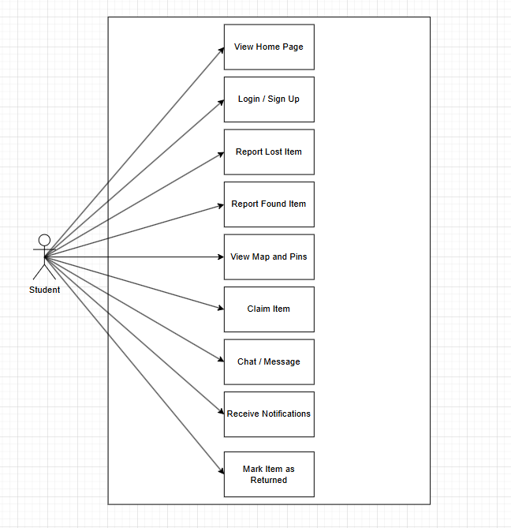

11.2 Activity Diagram
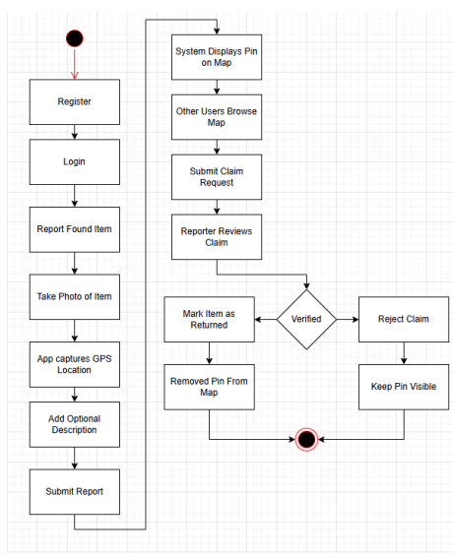

12.0 Implementation
4.1.1 Getting Started with the Lost and Found Hub
Users will begin by downloading the Lost and Found Hub app from their mobile app store. The app’s icon and landing page are designed to be clean, modern, and visually recognizable to encourage users to download it. As shown in Figure 1, users can create an account by providing a username, email, and password, or log in if they already have an account. The sign-up and login interfaces are kept simple to reduce friction during the onboarding process. Users may also choose to continue as a guest, though this option provides limited functionality.
After signing in, the app will request permissions for location services and camera access. These permissions are essential for posting found items, attaching GPS coordinates, and browsing nearby reports. Once permissions are granted, the user is directed to the home screen, which displays an interactive campus map with pins representing recently reported lost or found items. This gives the user an immediate overview of current activity and available reports within their area.

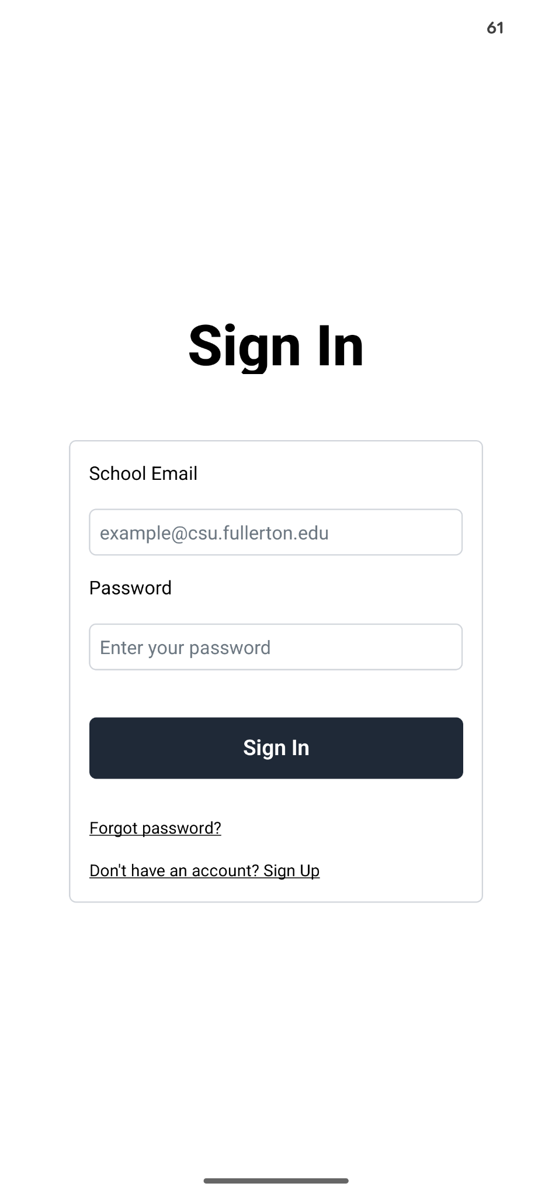
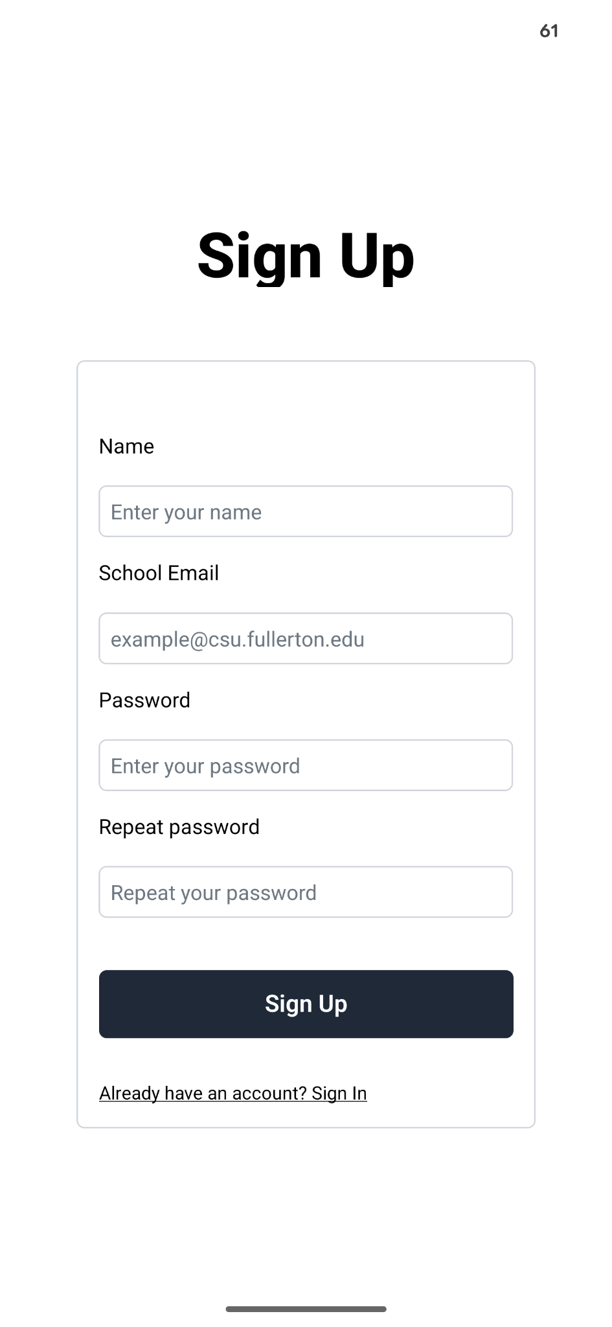
Figure 1 Lost and Found Sign Up
4.1.2 Reporting a Found Item
As shown in Figure 2, users are welcomed with an interactive map that highlights nearby lost and found reports. The interface includes zoom controls, a recenter button, and a floating action button for reporting items. At launch, the app prompts the user to grant location access so pins can be placed accurately and nearby reports can be displayed in real time.
In addition to browsing reports, users can interact directly with the map to explore specific items in more detail. Tapping on a pin opens a summary of the item, including its category, location, and time reported. This interaction allows users to quickly determine whether a report is relevant before taking further action. The map-based design minimizes search effort and improves accessibility for users navigating large campus areas. Overall, this interface supports efficient discovery and engagement with lost and found reports.
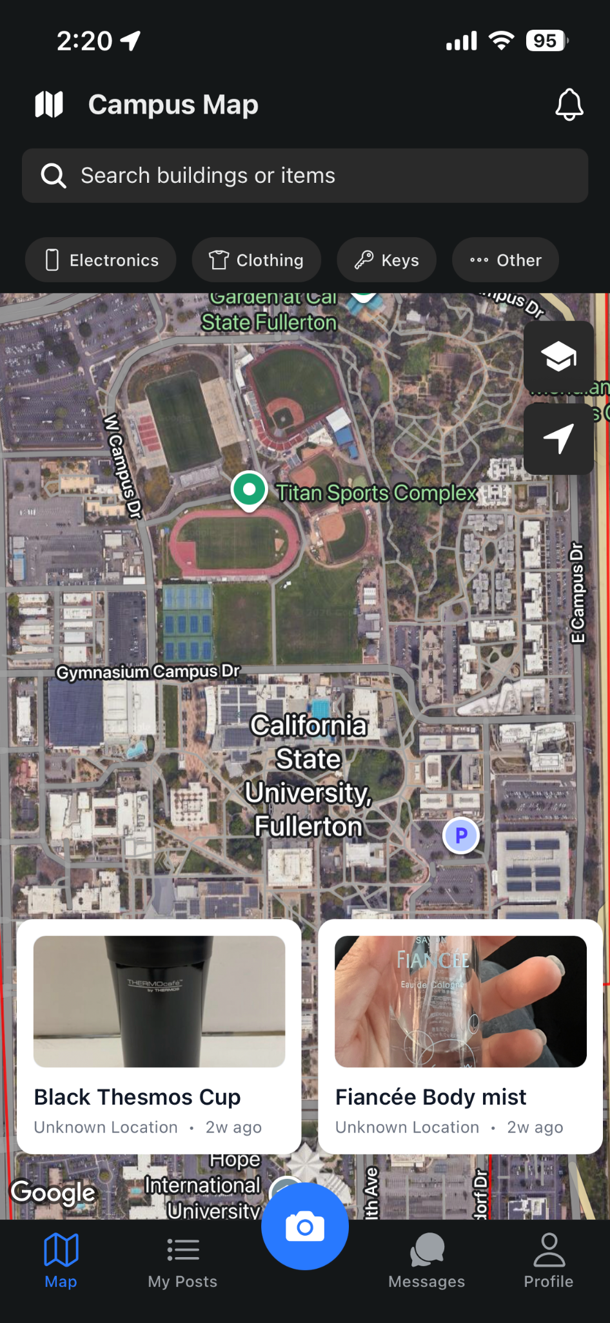
Figure 2 Lost and Found App: Welcoming Page

4.1.3 Reporting a Found Item
When a user discovers an item on campus, the Report a Found Item interface allows for fast and convenient reporting. The first step prompts the user to take or upload a photo of the item. After the image is selected, the app automatically detects the user’s current GPS location and assigns it as the found location. Users can then add a short description to help identify the item. Finally, the user selects a category such as electronics, keys, or personal accessories and confirms the time the item was found.
After the form is submitted, the item immediately appears on the shared map as a new pin visible to all users. This real-time update ensures that newly found items are quickly accessible to the campus community. Students who previously reported a similar item as lost receive a notification when a match appears. These notifications allow students to review the report and verify whether the item belongs to them. Overall, this system increases the likelihood of successfully returning lost items to their owners.
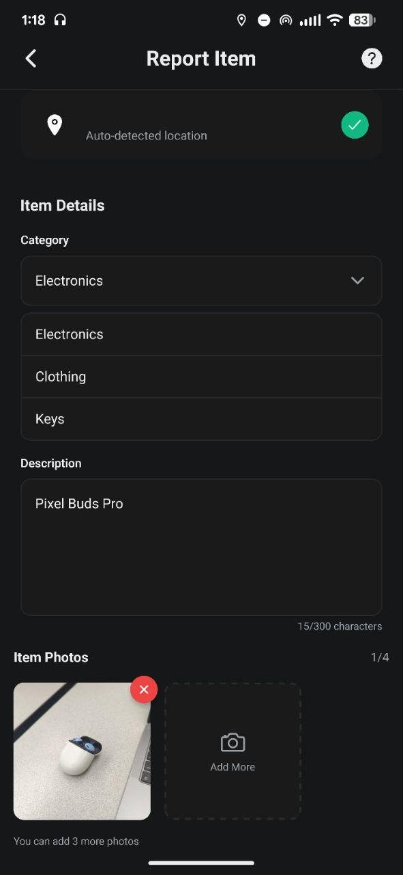
Figure 3 Lost and Found App Report a Found Item
13.0 Testing and Integration
The application can be tested and run by cloning the repository or downloading the project zip file. After extracting the contents, navigate to the project directory and run npx expo start in a terminal. From there, the application can be launched on a physical device using the Expo Go app by scanning the QR code, or on an emulator through Android Studio or Xcode. A test account login can be found in the readme provided with the project.
14.0 Installation Instructions
Before running the application, it is important to have Node.js and npm installed on the system. Once confirmed, navigate to the project directory and run npm install to download all required dependencies. The key packages used include Expo, React Native, Firebase, NativeWind, and Turf.js, all of which are listed in the package.json file and will be installed automatically. Installation may vary slightly between operating systems, particularly for iOS simulation, which requires a macOS environment with Xcode installed.
15.0 Recommendations for Enhancement
Future improvements involve the addition of push notifications. This will allow users to receive real-time alerts when a new item matching their lost report is posted on campus. Currently, users must manually check the map for updates. Another improvement would be the implementation of an admin moderation panel. This would allow campus staff to review, flag, or remove inappropriate reports. Additionally, expanding the geofencing system to support multiple campuses would make the application scalable beyond CSUF, requiring minimal reconfiguration to deploy at other Cal State institutions.

16.0 References
Ihrig, Colin J. “Finding Yourself Using Geolocation and the Google Maps API.” Crossroads (Association for Computing Machinery), vol. 19, no. 1, 2012, pp. 72–74, https://doi.org/10.1145/2331042.2331065.
S. Noh, J. Han, J. Jo and A. Choi, "Virtual Companion Based Mobile User Interface: An Intelligent and Simplified Mobile User Interface for the Elderly Users," 2017 International Symposium on Ubiquitous Virtual Reality (ISUVR), Nara, Japan, 2017, pp. 8-9, doi: 10.1109/ISUVR.2017.10. keywords: {Senior citizens;User interfaces;Monitoring;Mobile communication;Meteorology;Animation;Speech recognition;Virtual companion;intelligent user interface;visualization in 3D},
E. Sediyono, K. I. Santoso and Suhartono, "Secure login by using One-time Password authentication based on MD5 Hash encrypted SMS," 2013 International Conference on Advances in Computing, Communications and Informatics (ICACCI), Mysore, India, 2013, pp. 1604-1608, doi: 10.1109/ICACCI.2013.6637420. keywords: {Authentication;Cryptography;Information systems;Educational institutions;Logic gates;Mobile handsets;Academic Information System;Login;MD5 Hash;One Time Password;SMS},
E. Sediyono, K. I. Santoso and Suhartono, "Secure login by using One-time Password authentication based on MD5 Hash encrypted SMS," 2013 International Conference on Advances in Computing, Communications and Informatics (ICACCI), Mysore, India, 2013, pp. 1604-1608, doi: 10.1109/ICACCI.2013.6637420. keywords: {Authentication;Cryptography;Information systems;Educational institutions;Logic gates;Mobile handsets;Academic Information System;Login;MD5 Hash;One Time Password;SMS},
E. Sediyono, K. I. Santoso and Suhartono, "Secure login by using One-time Password authentication based on MD5 Hash encrypted SMS," 2013 International Conference on Advances in Computing, Communications and Informatics (ICACCI), Mysore, India, 2013, pp. 1604-1608, doi: 10.1109/ICACCI.2013.6637420. keywords: {Authentication;Cryptography;Information systems;Educational institutions;Logic gates;Mobile handsets;Academic Information System;Login;MD5 Hash;One Time Password;SMS},
Nakada, Toyohisa, et al. “A Support System for Finding Lost Objects Using Spotlight.” MobileHCI 05 : Proceedings of the 7th International Conference on Human Computer Interaction with Mobile Devices and Services : 19 to 22 September 2005, Salzburg, Austria, ACM, 2005, pp. 321–22, https://doi.org/10.1145/1085777.1085846.

